Lesson: Rhetorical Grammar, Mechanics, and Punctuation Module

Objective:
Students will leave class understanding that grammar is rhetorical, and will be able to think about grammar and punctuation in relation to audience, purpose, and context. Students will also be able to articulate correct and effective uses for multiple punctuation marks.

Begin lesson with brief video:
- Introduce: Pinker, ask students to think about connections as Pinker describes choosing to use profanity in various situations with other language choices
- Content Warning
- Play: https://www.youtube.com/watch?v=6H7utm3eco4
- Group conversation about mapping out video, profanity is:
  - Rhetorical (audience and purpose) - the wife, etc.
  - History and culture - the evolution of language and grammar
  - Prescriptive
  - Illustrates the emotional impact and ALSO the social implications
- Think about how Pinker’s arguments, then, tie to rhetorical grammar. What are the connections they can see between Pinker’s statements about profanity and grammar/word usage/punctuation?

Then, students respond in writing to Koln and Gray excerpt:

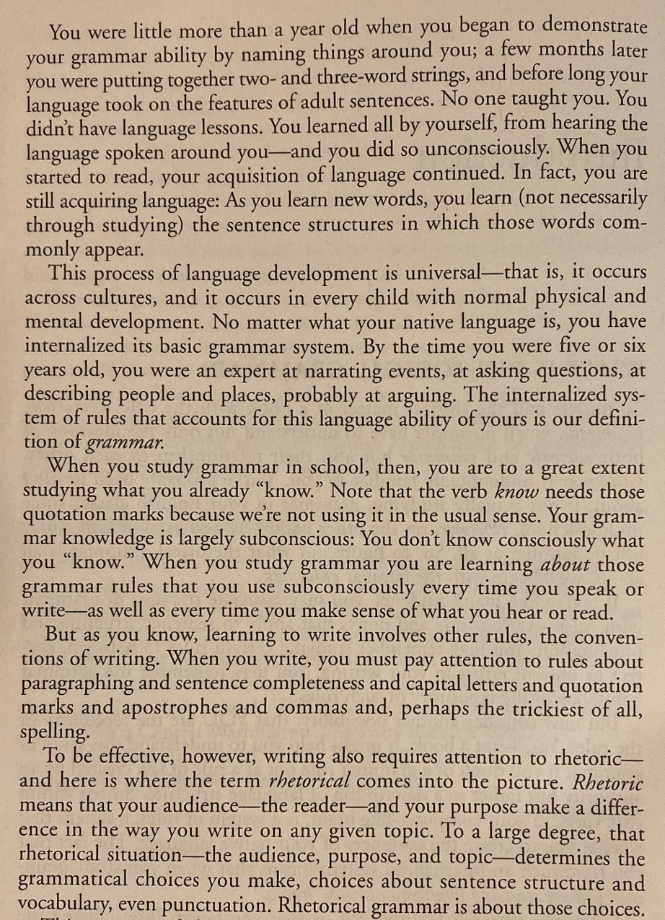
Read: Read the excerpt to the left from Kolln and Gray’s Rhetorical Grammar: Grammatical Choices, Rhetorical Effects

Write:
What does the word “grammar” mean to you? What have your experiences with learning or using grammar been like, either as a child or as an adult? Also, what “rules” do you remember being taught? What grammar “rules” do you still struggle with?

Large group discussion/responses from writing:

- Is grammar important? Why?
- What does the word “grammar” mean to you? What have your experiences with learning or using grammar been like, either as a child or as an adult? Also, what “rules” do you remember being taught? What grammar “rules” do you still struggle with?
- Shift to what they remember learning and what they wish they’d learned.

My mini-lecture notes:

Today, we’ll talk about it in a way that might be new to you to really begin to think about how and why we might start to think about grammar as something we use strategically in order to be more effective in our writing; rather than as something we “mess up” or something that can detract from our writing. Usually, we come to grammar conversations thinking about correctness. Today I want to shift our thinking to think about it rhetorically.

What is rhetorical grammar? Term “rhetorical grammar” coined by Kolln in 1996
– Going beyond correctness to use language and sentences and punctuation as effectively as possible for persuasion and other goals related to audience, purpose, topic, genre, etc.

An example we sometimes see: passive vs. active voice

Mistakes were made.
vs.
I made a mistake.

Passive vs. active—this is a grammar choice (what kind of sentence structure you want to use, but it’s also a rhetorical choice (do I want to own up to this mistake?).

We’ll focus on punctuation as an element of grammar today. We’ll focus on words next session.

We know punctuation can change meaning:

A woman, without her man, is nothing.
A woman: without her, man is nothing.

or

The teacher said the student is smart.
The teacher, said the student, is smart.

But it can also alter our reading without officially changing meaning. Punctuation can emphasize, de-emphasize, express feelings, can pace our reading…

Punctuation can also tell us how familiar and comfortable a writer is with various forms. [Offer and solicit examples re: audience/genre]

As a large group:

Look to variations, discuss connotations:

  - The organization fired half of its employees; the remaining professionals will be tasked with picking up their slack.
  - The organization fired half of its employees! The remaining professionals will be tasked with picking up their slack!
  - The organization fired half of its employees—the remaining professionals will be tasked with picking up their slack.
All are grammatically correct. Yet, they take on certain meanings. What subtle (or not so subtle) differences do you see in the way these sentences read? What audience do you imagine #2 is geared toward and why?

Rhetorical Punctuation Activity:

*Activity to start framing punctuation as rhetorical, just like all other grammar. Framing it as grammar (punctuation) in context.

You read three articles on punctuation--on preferences related to punctuation: The em-dash the semicolon, and the exclamation point. They are useful and helpful with readability, but also not ever “required” or essential. Now, in small groups (assigned by me) in a Google doc, you will:
- Map out actual “rules” of each mark.
- Discuss connotations and informal uses/choices of each.
- Read your assigned passage (Gay, Wolfe, or King - one for each punctuation mark). Answer (in that same Google doc):
  - What rhetorical advantage do you see to its use? (You’ll want to focus here on audience and purpose.)
  - Mark or otherwise note the other punctuation choices in the text. Are any “noteworthy” or unexpected? What do they “do” for text?
  - Does the text break any grammar or punctuation “rules”? Which ones? To what effect?
  - As a group, change at least four punctuation marks, without changing any of the text. In what ways does this change your reading of the writing?

Handout for groups:
Rhetorical Punctuation Activity

Em-Dash Group
“The notion that thinness—and the attempt to force the fat body toward a state of culturally mandated discipline—begets great rewards is centuries old.
Modern weight-loss surgery began in the 1950s, when surgeons employing various techniques caused their patients fairly distressing problems, like severe diarrhea, dehydration, kidney stones, gallstones, and even death—but, generally, the patients lost weight. Surgeons have since refined their techniques, using a range of restriction or malabsorption methods to force the human body to lose weight. They have tried wiring patients’ jaws shut to force weight loss through liquid diets. They have stapled stomachs into smaller pouches to restrict caloric intake. They have developed gastric bands and balloons to restrict the amount of food that can enter the stomach. But it was the first laparoscopic gastric bypass—in which the gastrointestinal tract is routed around a person’s stomach—performed in 1994, that enabled bariatric surgery to go more mainstream by way of minimal invasion.” – Roxanne Gay, “What Fullness Is”

Exclamation Point Group
“Starting time! Linda Vaughn, with the big blonde hair and blossomy breasts, puts down her Coca-Cola and the potato chips and slips off her red stretch pants and her white blouse and walks out of the officials' booth in her Rake-a-cheek red showgirl's costume with her long honeydew legs in net stockings and climbs up on the red Firebird float. The Life Symbol of stock car racing! Yes! Linda, every luscious morsel of Linda, is a good old girl from Atlanta who was made Miss Atlanta International[…]Linda gets up on the Fire-bird float. This is an extraordinary object, made of wood, about twenty feet tall, in the shape of a huge bird, an eagle or something, blazing red, and Linda, with her red showgirl's suit on, gets up on the seat, which is up between the wings, like a saddle, high enough so her long honeydew legs stretch down, and a new car pulls her—Miss Firebird!—slowly once around the track just before the race. It is more of a ceremony by now than the national anthem. Miss Firebird sails slowly in front of the stands and the good old boys let out some real curdle Rebel yells, "Yaaaaaaaaaaaaghhhhoooooo! Let me at that car!" "Honey, you sure do start my motor, I swear to God!"” – Tom Wolf, “The Last American Hero”

Semicolon Group
“For more than two centuries our forebears labored in this country without wages; they made cotton king; they built the homes of their masters while suffering gross injustice and shameful humiliation—and yet out of a bottomless vitality they continued to thrive and develop. If the inexpressible cruelties of slavery could not stop us, the opposition we now face will surely fail. We will win our freedom because the sacred heritage of our nation and the eternal will of God are embodied in our echoing demands. Before closing I feel impelled to mention one other point in your statement that has troubled me profoundly. You warmly commended the Birmingham police force for keeping "order" and "preventing violence." I doubt that you would have so warmly commended the police force if you had seen its dogs sinking their teeth into unarmed, nonviolent Negroes. I doubt that you would so quickly commend the policemen if you were to observe their ugly and inhumane treatment of Negroes here in the city jail; if you were to watch them push and curse old Negro women and young Negro girls; if you were to see them slap and kick old Negro men and young boys; if you were to observe them, as they did on two occasions, refuse to give us food because we wanted to sing our grace together. I cannot join you in your praise of the Birmingham police department.” – MLK, “Letter from a Birmingham Jail”

End of session framing, in the form of an email or video from me:
In wrap-up conversation (to this activity and to overall module), think about moving back to initial conversation about past grammar experiences and discomforts. How can grammar be empowering when we think of it rhetorically? In what ways can we anticipate thinking about grammar rhetorically in technical communication work?

Extra reading, if you’re into it:
- “Semicolons: A Love Story” by Ben Dolnik, New York Times
- “The Em Dash Divides” by Kate Mooney, New York Times
- “A Plea for Self-Control Regarding the Exclamation Point” by Rembert Brown, The Atlantic

